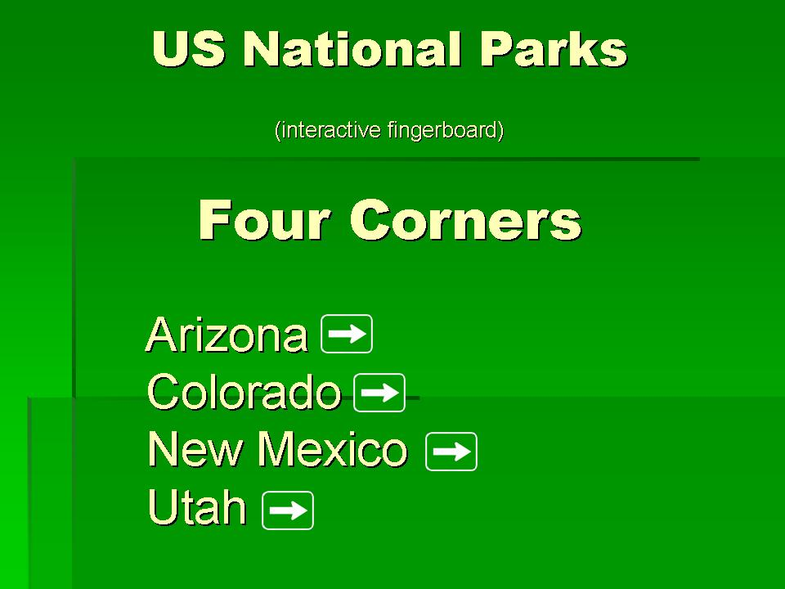

The Four Corners is a region of the United States consisting of the southwestern corner of Colorado, northwestern corner of New Mexico, northeastern corner of Arizona, and southeastern corner of Utah. The Four Corners area is named after the quadripoint where the boundaries of the four states meet, where the Four Corners Monument is located. It is the only location in the United States where four states meet. Most of the Four Corners region belongs to semi-autonomous Native American nations, the largest of which is the Navajo Nation, followed by Hopi, Ute, and Zuni tribal reserves and nations. The Four Corners region is part of a larger region known as the Colorado Plateau and is mostly rural, rugged, and arid. In addition to the monument, commonly visited areas within Four Corners include Monument Valley, Mesa Verde National Park, Chaco Canyon, and Canyon de Chelly National Monument. The most populous city in the Four Corners region is Farmington, New Mexico, followed by Durango, Colorado.

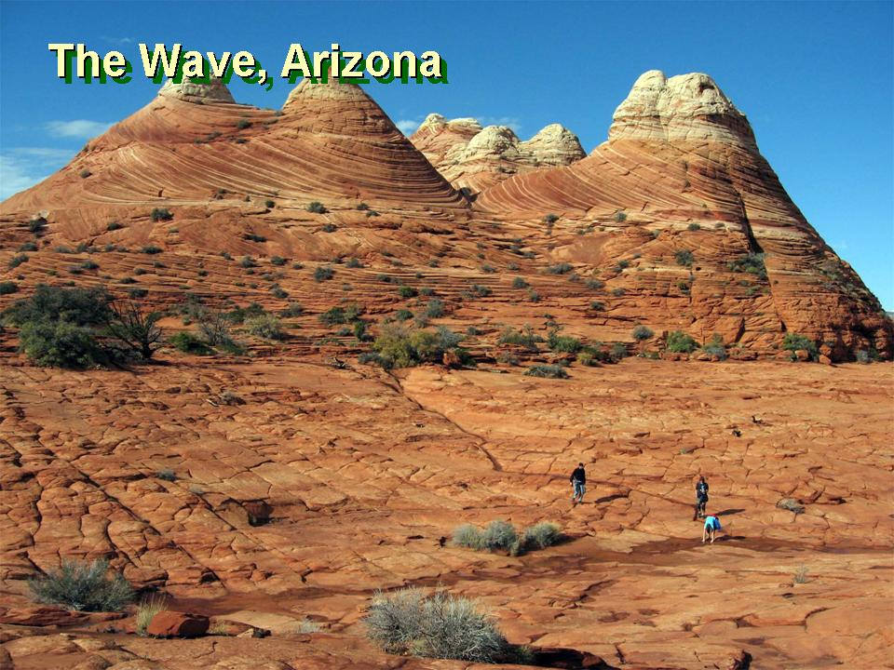

The Wave exposes large-scale, sets of cross-bedded eolian sandstone composed of rhythmic and cyclic alternating grainflow and windripple laminae. The rhythmic and cyclic alternating laminae represent periodic changes in the prevailing winds during the Jurassic as huge sand dunes migrated across a sandy desert. The thin ridges and ribbing seen within The Wave is the result of the differential erosion of rhythmic and cyclic alternating grainflow and windripple laminae within the Navajo Sandstone. These laminae have differing resistance to erosion as they have been differentially cemented according to variations in the grain size of the sand composing them. The soft sandstone, including the ridges and ribbing, of The Wave is fragile. As a result, persons must walk carefully to avoid breaking the small ridges.

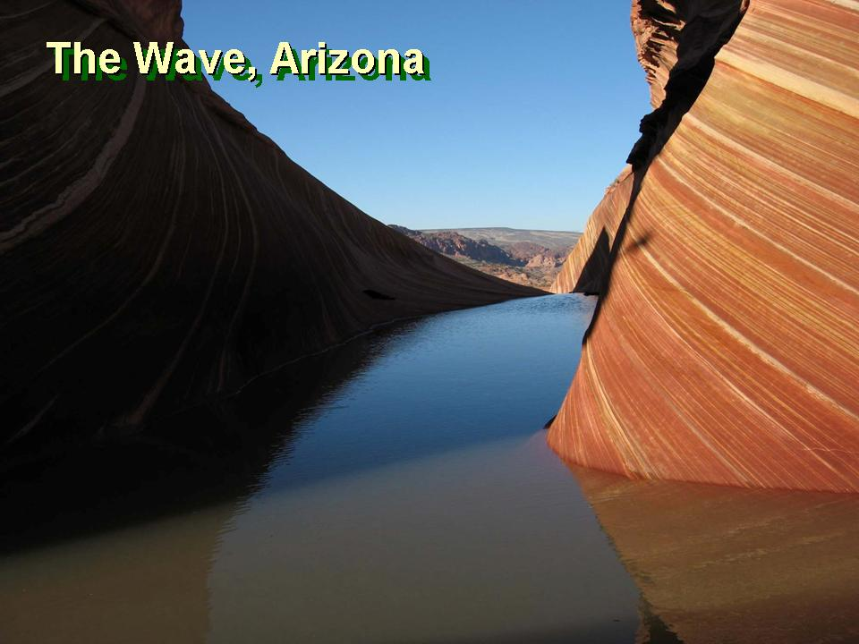

The Wave is a sandstone rock formation located in the United States of America near the Arizona–Utah border, on the slopes of the Coyote Buttes, in the Paria Canyon-Vermilion Cliffs Wilderness, on the Colorado Plateau. It is famous among hikers and photographers for its colorful, undulating forms, and the rugged, trackless hike required to reach it.

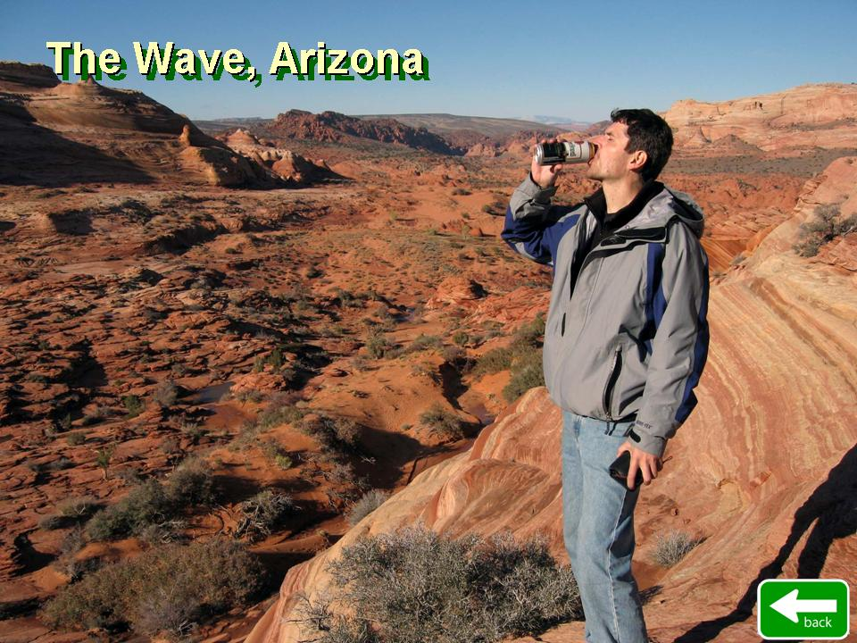

An ideal time to photograph The Wave is the few hours around midday when there are no shadows in the center, although early morning and late afternoon shadows can also make for dramatic photos. After a rain storm, numerous pools form which can contain hundreds of tadpoles and fairy shrimp. These pools can be present for several days.
Above and slightly west of The Wave is what many call "the middle Wave", which has fainter colors but is still of interest to most visitors and photographers. Hugo Martin from the Los Angeles Times said, "You can't call yourself a landscape photographer if you haven't snapped a photo or two of the Wave.

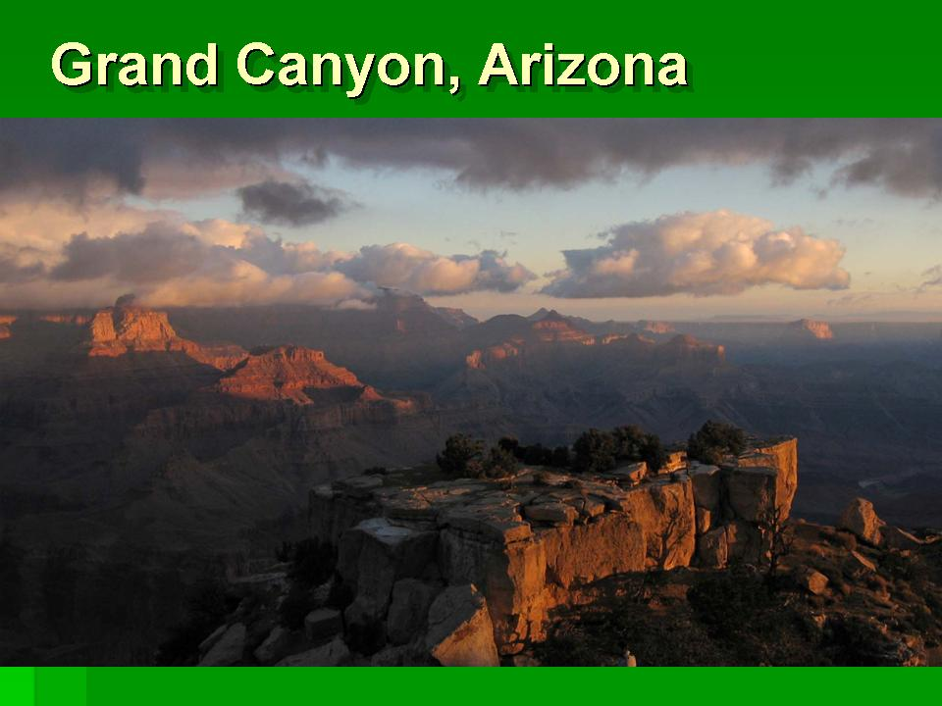

The Grand Canyon (Hopi: Ongtupqa; Yavapai: Wi:kaʼi:la, Spanish: Gran Cañón), is a steep-sided canyon carved by the Colorado River in the state of Arizona in the United States. It is contained within and managed by Grand Canyon National Park, the Kaibab National Forest, Grand Canyon-Parashant National Monument, the Hualapai Tribal Nation, the Havasupai Tribe and the Navajo Nation. President Theodore Roosevelt was a major proponent of preservation of the Grand Canyon area, and visited it on numerous occasions to hunt and enjoy the scenery.

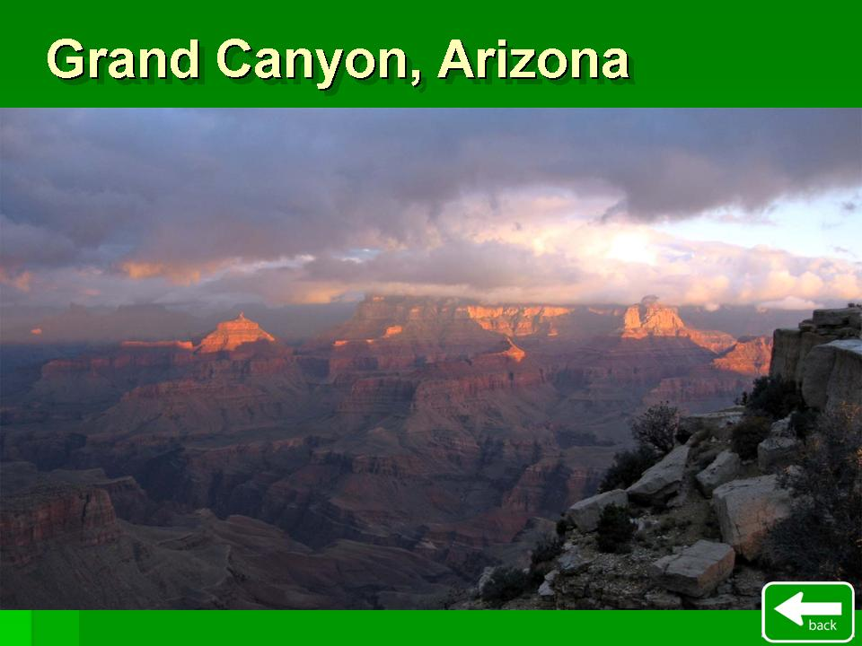

The Grand Canyon is 277 miles (446 km) long, up to 18 miles (29 km) wide and attains a depth of over a mile (6,093 feet or 1,857 meters).[1] Nearly two billion years of Earth's geological history have been exposed as the Colorado River and its tributaries cut their channels through layer after layer of rock while the Colorado Plateau was uplifted.[2] While the specific geologic processes and timing that formed the Grand Canyon are the subject of debate by geologists,[3] recent evidence suggests that the Colorado River established its course through the canyon at least 17 million years ago.[4][5] Since that time, the Colorado River continued to erode and form the canyon to its present-day configuration
For thousands of years, the area has been continuously inhabited by Native Americans who built settlements within the canyon and its many caves. The Pueblo people considered the Grand Canyon ("Ongtupqa" in the Hopi language) a holy site, and made pilgrimages to it.[7] The first European known to have viewed the Grand Canyon was García López de Cárdenas from Spain, who arrived in 1540.

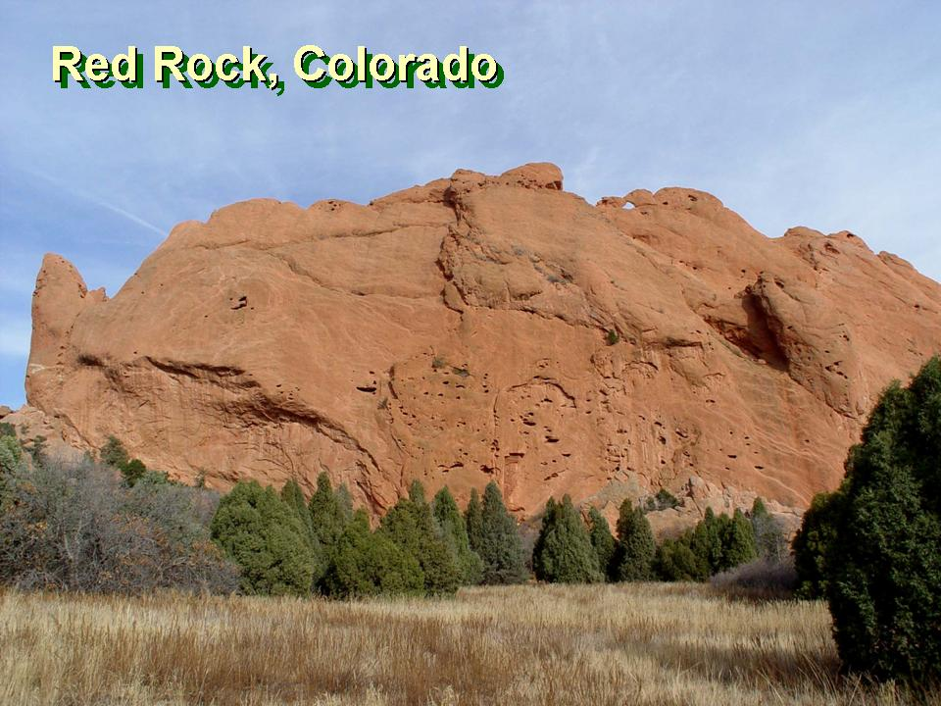

Red Rocks Park is a mountain park in Jefferson County, Colorado, owned and maintained by the city of Denver as part of the Denver Mountain Parks system. The park is known for its very large red sandstone outcrops. Many of these rock formations within the park have names, from the mushroom-shaped Seat of Pluto to the inclined Cave of the Seven Ladders. The most visited rocks, around the amphitheater, are Creation Rock to the north, Ship Rock to the south, and Stage Rock to the east.

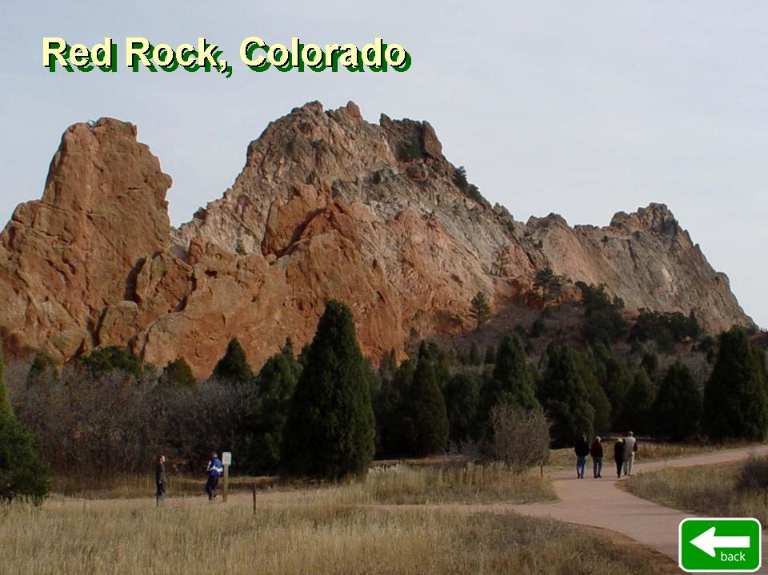

The red sandstone found throughout Red Rocks Park is geologically identified as belonging to the Fountain Formation.[2] Other Colorado examples of Fountain Formation geology include nearby Roxborough State Park, Garden of the Gods near Colorado Springs, and the Flatirons near Boulder. The rocks were formed about 290-296 million years ago when the Ancestral Rocky Mountains were eroded during the Pennsylvanian epoch. Later, uplift during the Laramide orogeny tilted the rocks to the angle at which they sit today.

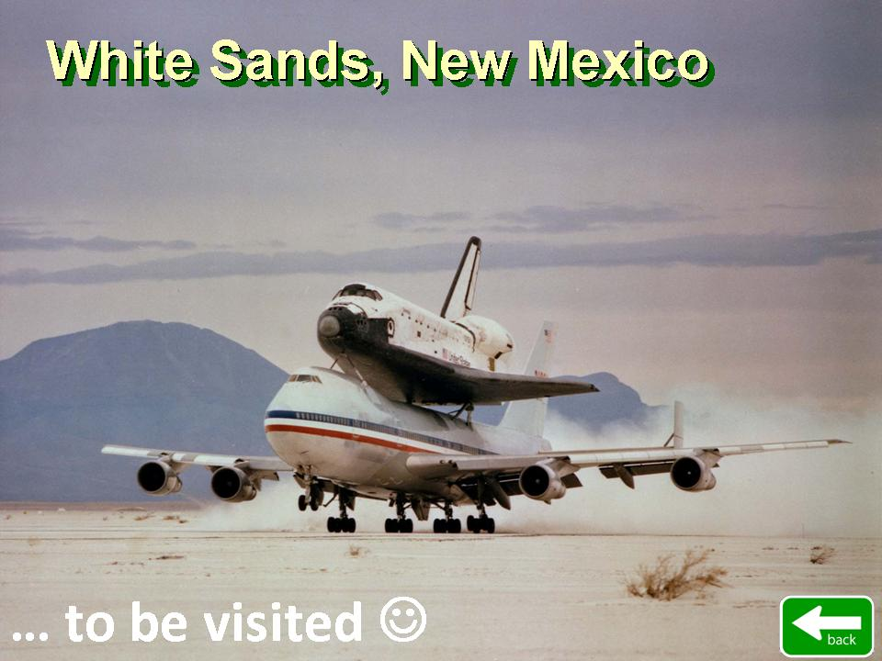

White Sands Space Harbor (WSSH) was a Space Shuttle runway, a test site for rocket research, and the primary training area used by NASA for Space Shuttle pilots practicing approaches and landings in the Shuttle Training Aircraft and T-38 Talon aircraft. With its runways, navigational aids, runway lighting, and control facilities, it also stood continuously ready as a backup Shuttle landing site.[1] WSSH is a part of the White Sands Test Facility, and is located approximately 30 miles (50 kilometers) west of Alamogordo, New Mexico, within the boundaries of the White Sands Missile Range.

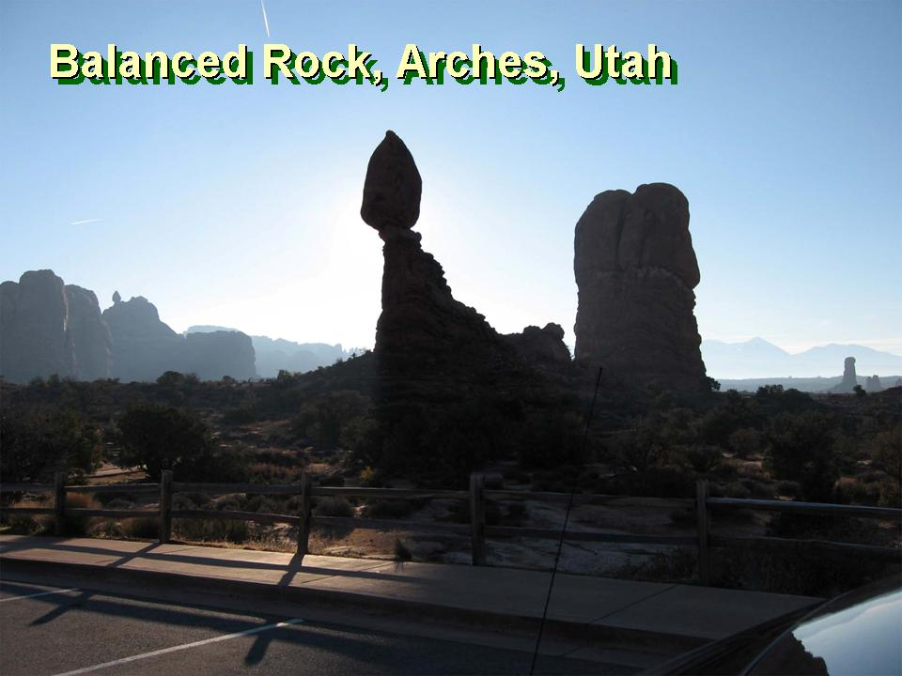

Balanced Rock is one of the most popular features of Arches National Park, situated in Grand County, Utah, United States. Balanced Rock is located next to the park's main road, at about 9 miles (14.5 km) from the park entrance.
The total height of Balanced Rock is about 128 feet (39 m), with the balancing rock rising 55 feet (16.75 m) above the base. The big rock on top is the size of three school buses. Until recently, Balanced Rock had a companion - a similar, but much smaller balanced rock named "Chip Off The Old Block", which fell during the winter of 1975/1976.
Balanced Rock can be seen from the park's main road. There is also a short loop trail leading around the base of the rock.[1] Balanced rock was formed through a process known as weathering.

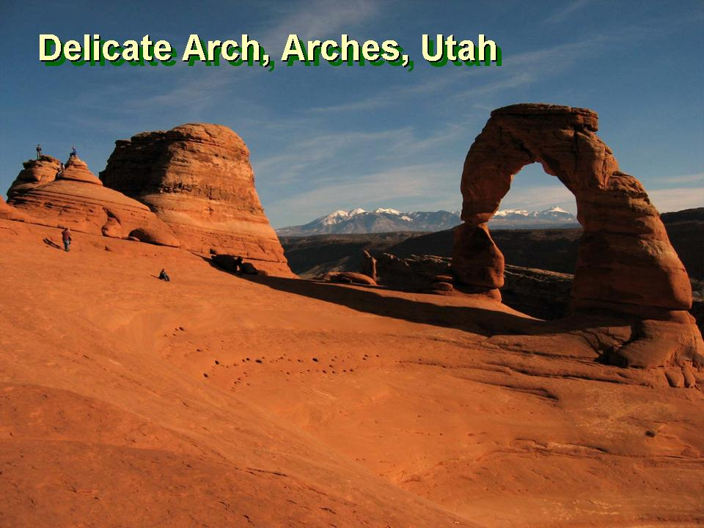

Delicate Arch is a 65-foot-tall (20 m) freestanding natural arch located in Arches National Park near Moab, Utah, USA.[1] It is the most widely recognized landmark in Arches National Park and is depicted on Utah license plates and on a postage stamp commemorating Utah's centennial anniversary of statehood in 1996. The Olympic torch relay for the 2002 Winter Olympics passed through the arch.

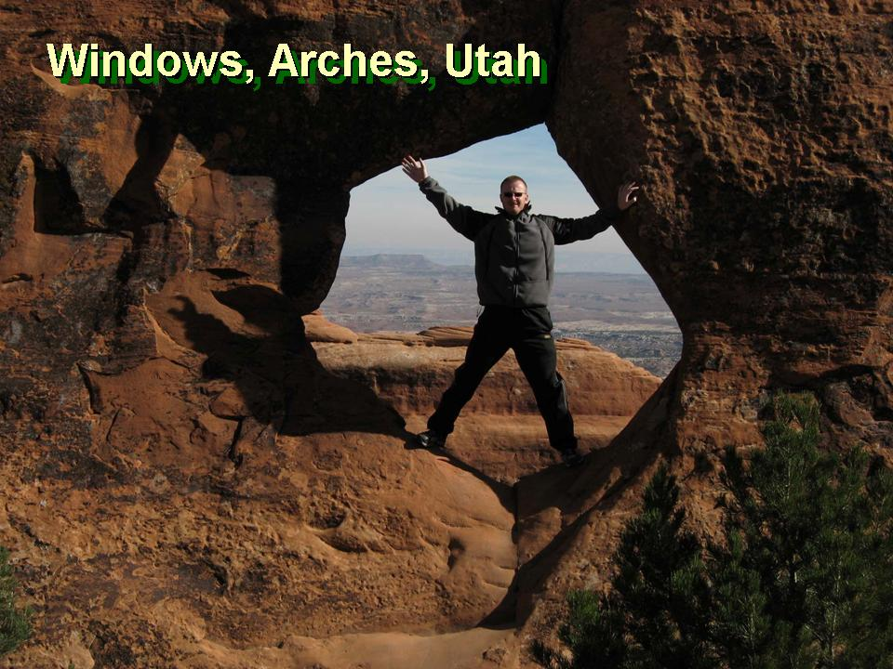

Arches National Park is a US National Park in eastern Utah. The park is located on the Colorado River 4 miles (6 km) north of Moab, Utah. It is known for containing over 2,000 natural sandstone arches, including the world-famous Delicate Arch, in addition to a variety of unique geological resources and formations.
The park is located just outside of Moab, Utah, and is 76,679 acres (119.811 sq mi; 31,031 ha; 310.31 km2) in area.[3] Its highest elevation is 5,653 feet (1,723 m) at Elephant Butte, and its lowest elevation is 4,085 feet (1,245 m) at the visitor center. Forty-three arches are known to have collapsed since 1977. The park receives 10 inches (250 mm) of rain a year on average.
Administered by the National Park Service, the area was originally named a National Monument on April 12, 1929. It was redesignated as a National Park on November 12, 1971.

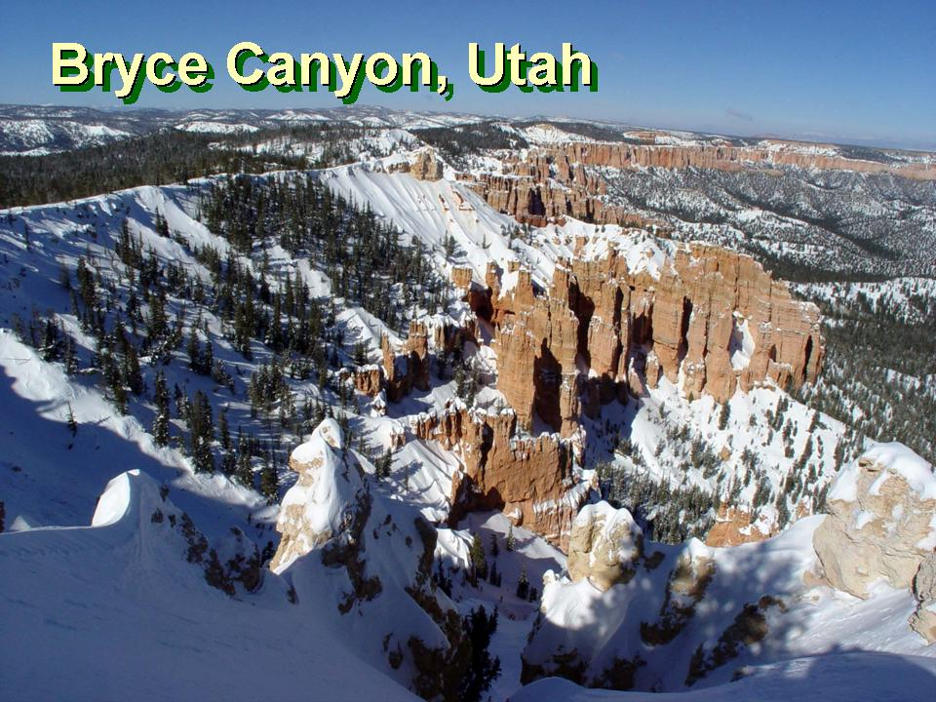

Bryce Canyon National Park is a national park located in southwestern Utah in the United States. Contained within the park is Bryce Canyon. Despite its name, this is not actually a canyon, but rather a giant natural amphitheater created by erosion along the eastern side of the Paunsaugunt Plateau.

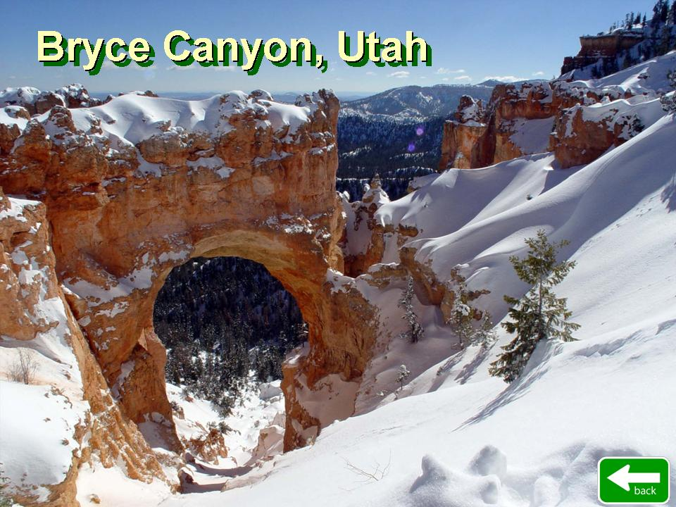

The Bryce Canyon area was settled by Mormon pioneers in the 1850s and was named after Ebenezer Bryce, who homesteaded in the area in 1874.[3] The area around Bryce Canyon became a National Monument in 1923 and was designated as a National Park in 1928. The park covers 35,835 acres (55.992 sq mi; 14,502 ha; 145.02 km2)[1] and receives relatively few visitors compared to Zion National Park and the Grand Canyon, largely due to its remote location.

